# Get started

# STEP 1. Download and install python

https://www.python.org/

# STEP 2. Download and install firefox (Yes, Doris wants firefox!!!!)

<https://www.mozilla.org/en-US/firefox/new/>

# STEP 3. Get firefox web driver.

https://github.com/mozilla/geckodriver/releases

Then put the webdriver file, **geckodriver.exe**, on your environment PATH

# STEP 3.1 If you don't know what you’re doing in STEP 3, then simply put the geckodriver.exe into C:\Windows\System32

# STEP 4. Install python package "Selenium"

https://selenium-python.readthedocs.io/installation.html

Minimise any window, Press down WIN+R to call up RUN Window. Enter "CMD" then press ENTER.

# STEP 5. then type "python -m pip install selenium" to install selenium, press enter and wait

# STEP 6. Try to get an IDE, for example, download Pycharm here:

<https://www.jetbrains.com/pycharm/download/#section=windows>

# STEP 7. Open the .py file. Change the ID and Password below to your own, keep the "" marks.

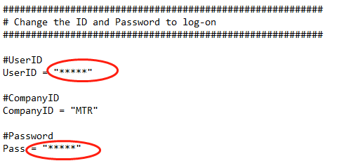

# STEP 7.1 RUN this file in PyCharm.

Right click the .py file and select Edit with PyCharm blablabla.

~~# STEP 8. If anything is not working, kindly ask the person who gave you this file to show you how it works.~~

# STEP 8. FILE – Setting – Project… - Python Interpreter

Then just choose whatever you have… SAVE/APPLY

# STEP 9. Go back to the code. Right click the code then choose

Run…..

*Or just press Ctrl+Shift+F10 (yes it’s hard)*

___________ Have fun debugging___________